Weeks 5 & 6 Exercise

Jon K. Jacobson
Bellevue University
DSC640 T301 2257: Data Presentation and Visualization
Dr. Ben Schneider
Due July 13, 2025

Audience
I think the ideal, critical audience for this information are current owners of Kias and Hyundais. These individuals need to know the risks they are currently facing by owning these devices and I think empowering them with this information is the most important thing to focus on.
Purpose
The purpose of this communication would be to warn owners of these vehicles, urge them to take precautions, and empower them to contact their manufacturer. Owners of these vehicles need to take precautions when leaving their vehicle in public areas and it would probably be good to register a complaint with the manufacturer and ask them for a resolution. If enough people did this, the manufacturer might put out a recall. I’m actually surprised this situation didn’t prompt a recall already.
Medium
A blog or newspaper article would be a good medium for this information. The goal would be to get the word out. I would love to conduct a public service campaign, but there probably wouldn’t be enough funding to make that possible. But perhaps getting the word out there might generate enough interest that something like this might materialize.
Design
I tried to simplify the visualizations as much as possible to keep the focus on the main points. I did allow light gridlines where I felt they emphasized the point by making the numerical comparisons easier. I used two complementary visualizations for Milwaukee to drive the point home just how rapidly Kia/Hyundai thefts increased there. I also zeroed in on the top cities where this has been occurring because car owners in these areas need to be especially cautious.

Ethical Considerations
Obviously, this situation touches on crime so it would be critical not to propagate information that would make these crimes easier to commit. I think most articles did an OK job with this, but there is a fine line between emphasizing how simple it is to steal one of these cars and providing the steps to do so. You would want car owners to know enough to protect themselves but not help thieves. Similarly, it would be a concern of mine that publicizing this information could inspire would-be criminals to take advantage of the chaos or even to target areas that are already hit hard by this situation. I think being very careful to work with the law enforcement agencies that are providing this information would be critical. Consulting with them would be an important step to make sure that the information they are providing is being used in a way that will help them with their jobs, not make their jobs harder.

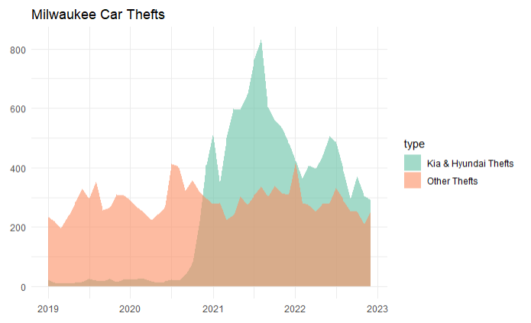
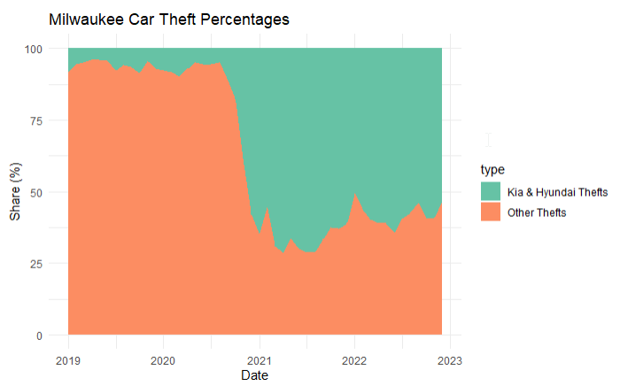

Stolen Kia/Hyundais by State and City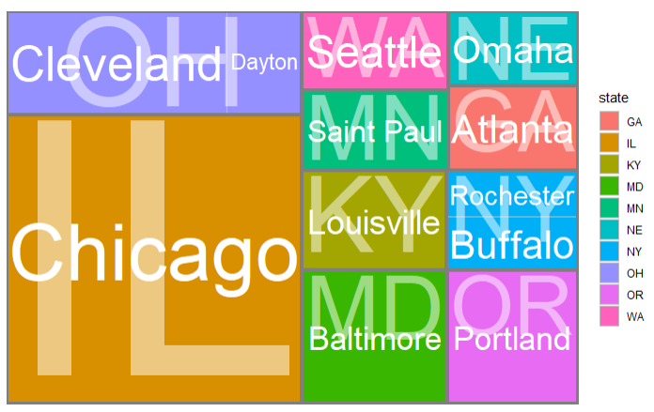
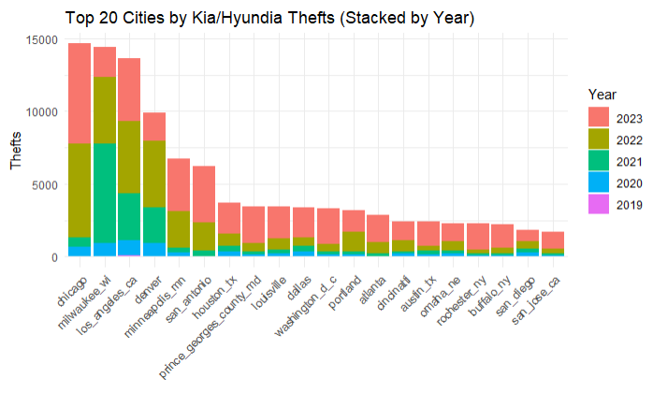

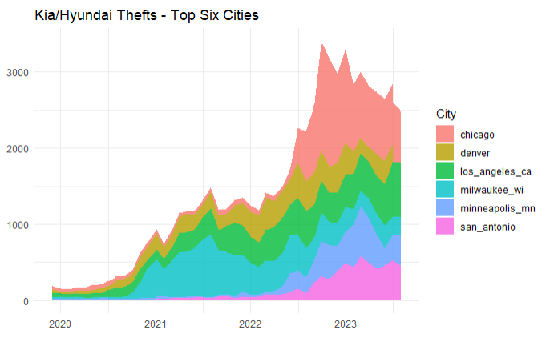
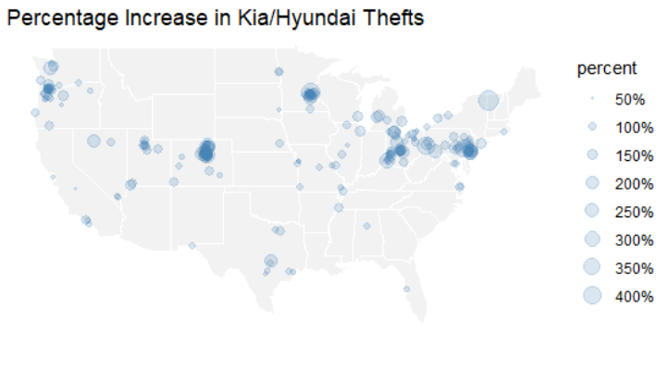

References
Gordon, A. (2023, September 21). U.S. Cities Have a Staggering Problem of Kia and Hyundai Thefts. This Data Shows It. VICE News. https://www.vice.com/en/article/us-cities-have-a-staggering-problem-of-kia-and-hyundai-thefts-this-data-shows-it.
Motherboard. (2023, September 21). Kia and Hyundai theft data across U.S. cities [Google Sheets dataset]. VICE News. https://docs.google.com/spreadsheets/d/1-6614t_Ata5k7oESrm-HAdF1uOe8aPGRaQECl44GYeE/edit#gid=0.
USAFacts. (2023, March 13). Car thefts in the United States. USAFacts. https://usafacts.org/data-projects/car-thefts](https://usafacts.org/data-projects/car-thefts.

